PLOW 24/7! 100% ILNICLIM

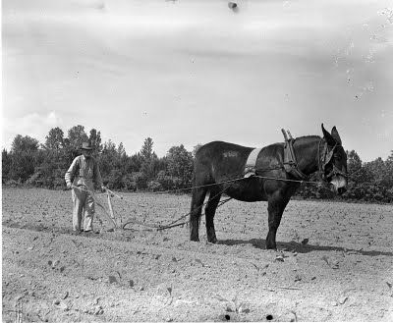

P PRAY THE MASS, PRAISE, WORSHIP, MEDITATION, THANKSGIVING, ND, CONTEMPLATION, SCRIPTURES, DIVINE OFFICE, ROSARY, DIVINE MERCY,
L LOVE GOD WITH ALL YOUR HEART, SOUL, MIND AND BODY (MBC)
LOVE YOUR NEIGHBOR AS YOURSELF, SELF-SACRIFICE, FAST, GIVE AWAY. HUMBLE YOURSELF AND PUT OTHERS FIRST, PUT GOD FIRST
O OBEDIENCE – NIGHT DUTIES, DO WHATEVER GOD (BIBLE) TELLS YOU TO DO; DO WHAT MARY TELLS YOU TO DO; DO WHAT YOUR PASTOR AND BISHOP TELL YOU TO DO; DO WHAT YOUR SPIRITUAL DIRECTOR TELLS YOU TO DO; DO WHAT YOUR CONSCIENCE TELLS YOU TO DO; BE ALSO A GOOD CITIZEN, A GOOD DEACON, A GOOD FATHER AND GRANFATHER, GOOD BROTHER, GOOD FRIEND. KEEP THE TEN COMMANDMENTS AND THE BEATITUDES AND THE GOLDEN RULE;
W WORK – SPIRITUAL WORK (READING, STUDYING), HOUSE WORK, CREATIVE WORK, WORK OUT (DIET AND EXERCISE, BC), PAY BILLS, PREACHING, TEACHING, POLITICAL ACTIVIST, SAVE BABIES! MAKE DISCIPLES. DO WHAT YOU DON’T WANT TO DO FIRST. DO THE WORK THAT GOD HAS GIVEN YOU TO DO. BE THE MAN GOD CREATED YOU TO BE. DO THE WORK OF REPENTANCE AND CHANGING YOUR LIFE. IF YOU BECOME A PLOW, THEN JESUS CAN USE YOU TO PLOW THE HARD HEARTS OF MEN, TO MAKE HARD SOIL RECEPTIVE TO THE WORD OF GOD, SO THAT THESE MEN CAN VENERATE JESUS IN THEIR HEARTS AND BEAR MUCH FRUIT.

