Green Tomatoes Journal 12th Issue
Friday May 18, 2023 “As long as you are green, you grow.”

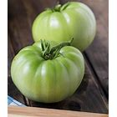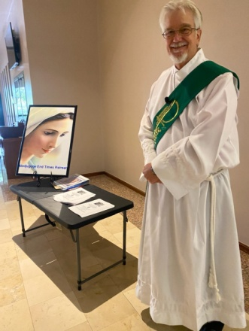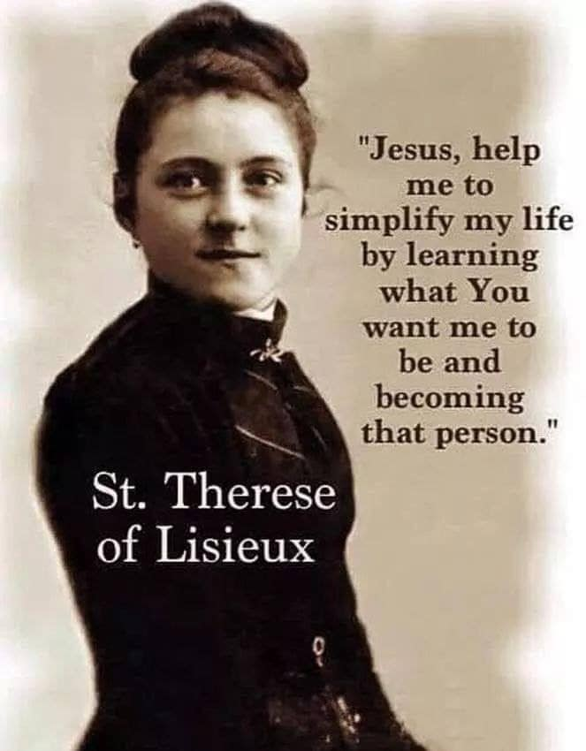
How Do I Get To Heaven?
Have you ever asked God, or a priest or deacon? “How do I get to heaven?” When Jesus walked the Holy Land, he proclaimed, “The Kingdom of God is as hand, repent and believe the Good News. (Mt). The bible says, “The just man shall live by faith.” Jesus said, “Not those who say, ‘Lord, Lord’ shall enter the kingdom, but those who do God’s will.” In Matthew’s 25th chapter we have the Last Judgment and many were surprised to enter heaven and many were surprised be condemned. We are all sinners, and some sinners return to God and many don’t.
Someone asked Jesus, “Will only a few be saved? He answered, “Enter through the narrow gate, because many will try to enter the kingdom, but will not be strong enough.” In Luke’s Gospel, Jesus said, “You will all perish if you don’t repent.” Fulton Sheen wrote, “A man without God is not like a cake without raisins, he is a cake without flour and milk, he hacks the essential ingredients.” What we need is grace and faith and Jesus in our hearts, amen?
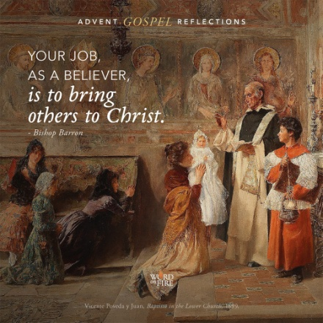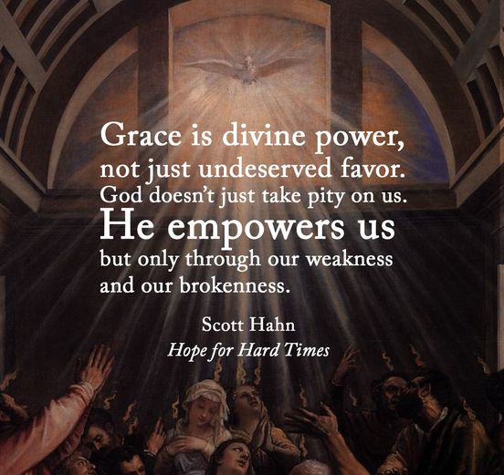
We need to be first, the do. Be A Christian, a disciple, a student who knows God, who knows Jesus Christ, knows the Holy Spirit, knows Sacred Scriptures, knows the teachings of the Catholic Church (CCC). Be a believer who listens to God and follows Jesus Christ. Be the Beatitudes: be meek, mournful, merciful, pure of heart, poor in spirit, be hungry for God and his righteousness, Be a child of God, a peacemaker, persecuted, true, be good, be virtuous, be diligent, be chaste, be wise. Be obedient, be love, be truth. Be in love with God, with his Church, with your neighbor. Be still, be present to God; be present to person in front of you.
Do the Ten Commandments, the Two Commandments, the New Commandment, the One Job: God’s Will. Do whatever God tells you to do. Imitate Jesus, Mary and the saints. Live a life worth imitating. Repent and believe the Good News. Be fruitful with the Holy Spirit (see Galatians 5). Act upon the teachings of Jesus and build your life on the rock that is God..
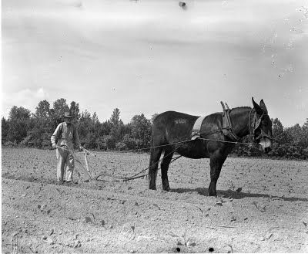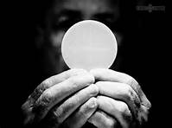
We need a balanced spiritual life. I propose an acronym that I have been using: PLOW
P stands for prayer; L stands for Love; O stands for obedience; W stands for work. We need to pray at least 30 minutes a day, it will help us to BE who God wants us to be. It will help us receive God’s love and then Love others in return. I heard a priest say, “If you don’t love, you are not a Christian.” Obedience is the proof of faith and love. Jesus said “If you love me, you will keep my commandments.” Work can be any task or duty that is our responsibility. We can’t be lazy Christians and expect to make it to heaven. Work also means studying our faith and serving our local church. Jesus said, “I came to serve, no be served. To give my life as a ransom.” St Catherine of Sienna said, “Be the person God created you to be and you will set the world on fire.” Read this out loud: “The world must know that I love God and I do what he commands me to do.” Can we make these words true?
I’m attaching some audio files: The Lonely Trail; A Soul Transformed and Be Simple, Be Holy. I am also attaching The Beatitude Poor in Spirit and Be Simple, Humble and Pure, as well as PLOW (my personal strategic plan).
I would like to invite you to my next retreat:
The Mass, The Host and The Mystical Body of Christ.
Saturday, July 15 2023 Holy Spirit Banquet Hall
8:00am to 2:30pm; Learn about the Mass: There is Nothing Better; What Can We Say about the Host? What is the Mystical Body of Christ? (the MBC?). I will be introducing Cowboy Bob and Professor Witt. $10 covers Continental breakfast, snacks, lunch, table discussions, prayer, praise and worship. Email me if you want to come.

I love you guys!

Deacon Evan G Wittig

