Green Tomatoes Journal 11th Issue
Saturday April 15, 2023 “As long as you are green, you grow.”

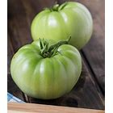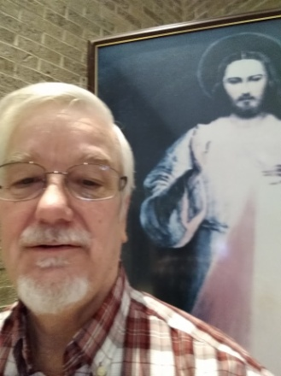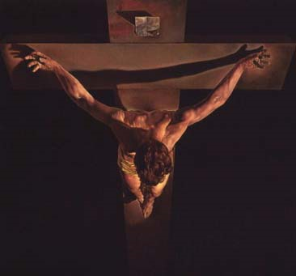
The Cross and the Empty Tomb
At every Mass we celebrate the Paschal Mystery, the passion, death and resurrection of Jesus Christ, the Son of God, God himself. Every Friday, we are invited to pray the Sorrowful Mysteries and meditate the Last Day of Jesus, beginning with the Last Supper, Gethsemane, the arrest, trial, scourging, crowning with thorns, carrying the cross and crucifixion and death on the cross. Forty days of Lent lead up to Holy Week. Now we are in the six weeks of Easter time. I would like to present a short reflection on the cross and the empty tomb.

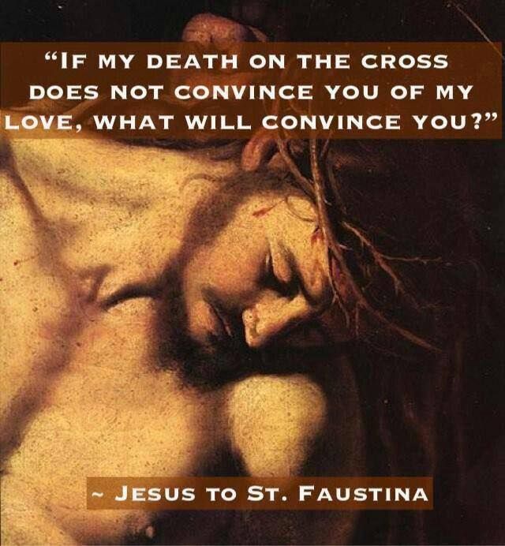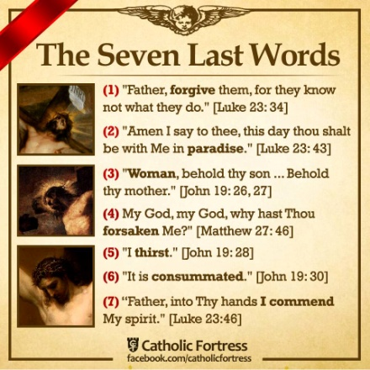
Thomas Aquinas wrote that Jesus had to suffer and die for us because we had a twofold need: we needed a remedy for sin and we needed an example of how to act. Aquinas wrote:
“It is a remedy, for, in the face of all the evils which we incur on account of our sins, we have found relief through the passion of Christ. Yet, it is no less an example, for the passion of Christ completely suffices to fashion our lives. Whoever wishes to live perfectly should do nothing but disdain what Christ disdained on the cross and desire what he desired, for the cross exemplifies every virtue.” In the cross we find a great example of love, no greater love, “And if he gave his life for us, then it should not be difficult to bear whatever hardships arise for his sake. If you seek patience, you will find no better example than the cross.” Consider how patiently and quietly Christ suffered all his torments. He is our model in learning obedience by suffering, “follow him who became obedient to the Father even unto death. For just as by the disobedience of one man, namely, Adam, many were made sinners, so by the obedience of one man, many were made righteous. If you seek an example of despising earthly things, follow him who is the King of kings and the Lord of lords, in whom are hidden all the treasures of wisdom and knowledge. Upon the cross he was stripped, mocked, spat upon, struck, crowned with thorns, and given only vinegar and gall to drink.

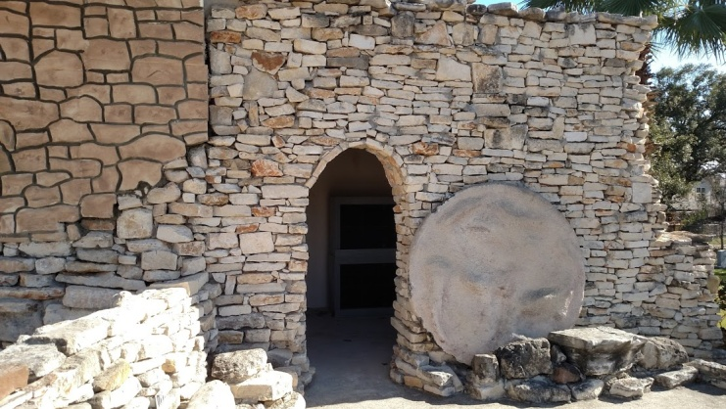
“Do not be attached, therefore, to clothing and riches, because they divided my garments among themselves. Nor to honors, for he experienced harsh words and scourging. Nor to greatness of rank, for weaving a crown of thorns they placed it on my head.”1 Our attachment is to Jesus Christ, all our treasures are hidden in him. Our honor and glory is in heaven with Jesus, a safe place, if only we suffer for just a little while, for being followers of The Way.

The empty tomb was met by shock and unbelief by Mary Magdalene and confusion by Peter and John. In Mark’s account, the Apostles did not believe Mary’s report of seeing the risen Lord and Jesus rebuked them for their unbelief (Mk 16). In John’s Gospel, even after Jesus rose from the dead, they hid in the upper room with the doors locked. We have had two thousand years to reflect on Easter Sunday, but many live as though Jesus has not risen from the dead. Is your Jesus stuck in the past, or is he alive for you today? Roll away the stone of your heart and let Jesus rise up within you and call you by name.
1 From a conference by St Thomas Aquinas (Divine Office January 28, 2022)

In honor of Divine Mercy Sunday, I’m attaching my “Divine Mercy” power point. I’m also attaching my “Glorious Mysteries” power point and three audio files: “Death Defeated,” “Eternal Life,” and my song “Christ Crucified.”

Divine Mercy Sunday features a plenary indulgence if you honor the Divine Mercy image, go to holy communion and go to confessions within 8 days before or after Divine Mercy .

I love you guys!

Deacon Evan G Wittig

