Green Tomatoes Journal 9th Issue
Monday, February 20, 2023 “As long as you are green, you grow.”

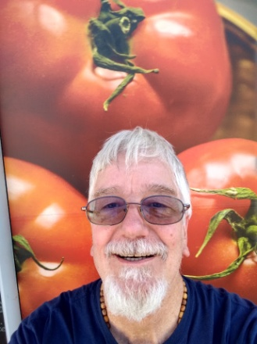
A Day with the Holy Spirit!
Saturday, January 28, 2023 I had my 6th Day of the Lord retreat.
The Knights of Columbus provided breakfast, lunch and snacks. My “A Team” of musicians provided great songs and singing. We had about 80 retreatants (including my team) who had
a great day with God. When the Son of God came from heaven and became man, the Holy Spirit came with him! The Holy Spirit is “The Forgotten God,” because he only points to Jesus and the Father, never himself. You can find him in the mysteries of the rosary, especially the Joyful and Glorious Mysteries. The Seven Gifts of the Holy Spirit produce the Twelve Fruits of the Holy Spirit. The Seven Deadly sins keep us from producing good fruit. The Holy Spirit is so much more than wind and fire. He is an Advocate, a Teacher who reminds us of the teachings of Jesus. He makes our faith, the bible and the sacraments all come alive! He is grace personified! He is love personified! The Holy Spirit comes when he is invited and he speaks to those who humbly listen to him. We all prayed the Glorious Mysteries before lunch. We had a prayer of repentance and a petition for the Holy Spirit to come to each of the retreatants. Table discussions and the fellowship of the retreatants were some of the highlights of the day. I am attaching some audio files and data files to give you a sample of our day. Use these attachments to help you grow in the knowledge of the Holy Spirit and grow in the desire of the Holy Spirit to infuse you with his gifts and produce within you greatest fruit, which is love, joy and peace.

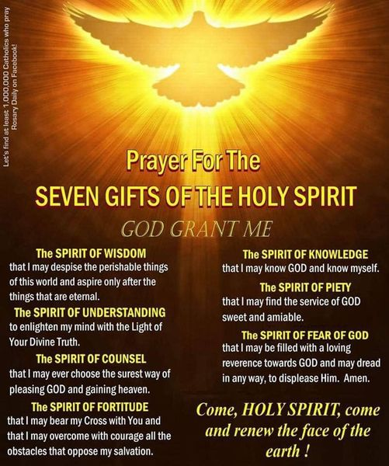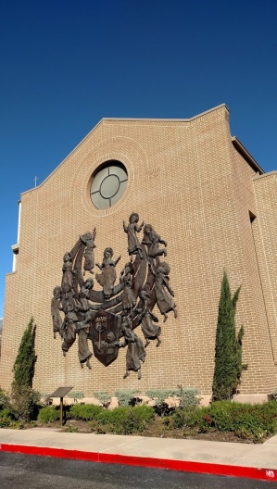
Metanoia by John Thomas
"Someone is going to die today." Preacher was visiting a prisoner named Mike, who seemed nervous and uneasy. He asked Mike: "Oh my God, who?" "No one knows, that's what makes us all nervous. “Mike, do me a favor, let Arrow know. I hope he is not in danger.” “I will, Pastor, I will.” Someone died that day. Who was it and why? Life in prison can be dangerous. Some would consider living in prison as living in hell. “God’s not here and he does not care about me,” many prisoners might think.
This book reflects my experiences as a chaplain and prison ministry. It also has a few of my homilies and reflections. It is a murder mystery novel with spiritual subject matter. There is a lesson in each chapter. The hero (Paul) is a Minister with a small congregation who is stalked by a professional assassin (Uno). He met with Uno in prison and began a plan to convert him. He recruited Arrow and his small band of brothers to evangelize Uno. Read how God’s plan unfolded. From a vision of heaven, to a vision of hell, you will see a true vision of reality.
Metanoia means to “change one’s way of thinking and acting.” It is like the change of a caterpillar to a butterfly. This book is for unbelievers who need to hear the truth about God and Jesus. It is also for believers who feel the need to become the person God created them to be. Let God change your heart! If you are interested in a copy of the book, let me know.
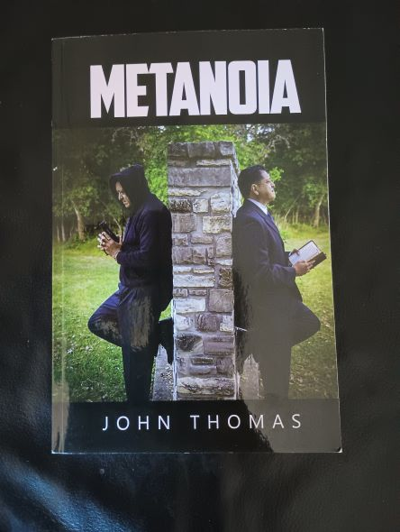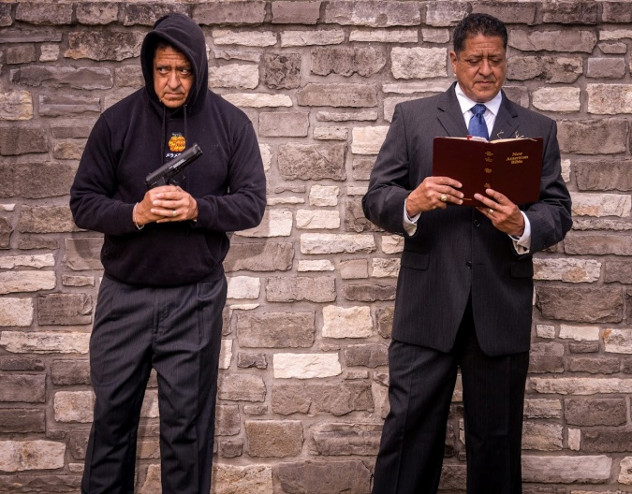
I invite you to attend a reading from my book, Monday March 13, 2023 from 7:00pm to 8:00pm. It will be in the St Rita room (the old Faith Formation office on first floor of Family Center) I will tell some of the stories behind the book and why I wrote it. Autographed books will be available for $18.00.
That’s it for now, thanks for reading the 9th Issue of Green Tomatoes!

I love you guys!

Deacon Evan G Wittig

