Green Tomatoes Journal 8th Issue
Thursday, January 12, 2023 “As long as you are green, you grow.”

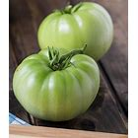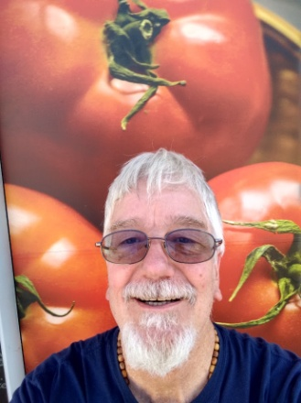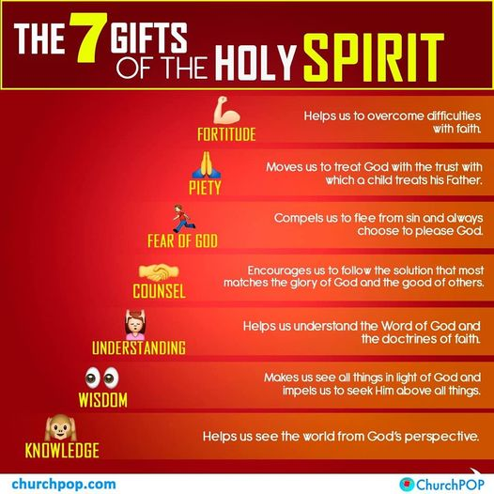
ANNOUNCING MY NEW BOOK!
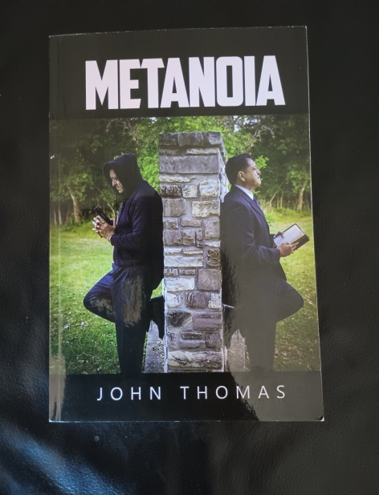 Metanoia by John Thomas
From the Preface:
"Someone is going to die today." Preacher was visiting a prisoner named Mike, who seemed nervous and uneasy. He asked Mike: "Oh my God, who?" "No one knows, that's what makes us all nervous. We all have enemies. There are gangs, feuds, rivalries, even love triangles. A guy could be killed for almost any reason around here.” “Mike, do me a favor, let Arrow know. I hope he is not in danger.” “I will, Pastor, I will.”
Someone died that day. Who was it and why? Life in prison can be dangerous, but even on a daily basis, some would consider living in prison as living in hell. “God’s not here and he does not care about me,” many prisoners might think.”
This book reflects my experiences as a chaplain and prison ministry. It also has a few of my homilies and reflections. It is a murder mystery novel with spiritual subject matter. I wanted to have some suspense to keep readers reading. There is a lesson in each chapter, including the last chapter. The hero (Paul) is a Minister with a small congregation who is stalked by a professional assassin! (Uno) He actually meets Uno in the hospital and gets the chills. He later meets with Uno in prison and begins a plan to convert him. He recruits Arrow and his small band of brothers to evangelize Uno. While many might think God is not in a prison, you will see God’s plan unfold. From a vision of heaven, to a vision of hell, the reality of both places is repeated for the sake of emphasis.
Metanoia means to change one’s way of thinking and acting. This book is for unbelievers who need to hear the truth about God and Jesus. It is also for believers who “hit a wall” and have stopped growing. Ask yourself: “Do I want to be like the thief on the cross, or do I want to be like Peter, who became a giant of the early church? God can change your heart, if you let him!
You are invited to attend “A Day with the Holy Spirit Retreat, More than Wind and Fire”
Saturday, January 28, 2023
Holy Spirit Banquet Hall 8134 Blanco Road, 78216. 8:00am to 2:30pm
Learn about the Holy Spirit, the Forgotten God. Did you know that the Holy Spirit is in the Rosary? Do you know how the Gifts of the Holy Spirit can produce the fruit of the Holy Spirit?
Jesus said, “You can tell a tree by its fruit.” When we think of Pentecost, we think of wind and fire, but the Holy Spirit is so much more than wind and fire. The retreat only cost $10 and that includes: continental breakfast, snacks, lunch and study materials. We will have table discussions, prayer, praise and worship. If you are interested, contact me by email egwittig@outlook.com or call 210-316-4495.If you want to come, copy and paste this link, https://form.jotform.com/230063975822054 or go to “Church of the Holy Spirit” website home page, scroll down and find announcement with link to register.
If you are one of my out of town friends, I will have a flash drive with all six of my retreats on it. It will be available for $15 plus $5 shipping. Retreat topics include: “The Day of the Lord, the Gospel of Joy,” “The Day of the Eucharist,” “Day of the Lord with Mary,” “Mary and the Rosary” “A Day with the Holy Family,” “Medugorje and the End Times,” “A Day with the Holy Spirit.” Flash Drive has a lot of files you can read and listen to. It also has Rosary video that you just play and pray the rosary. It has songs written by myself and my son, Anthony. You will like it, I guarantee!
If you are interested in “Metanoia,” contact me. The price is $18 plus $5 for shipping. I really believe this book can save souls!
That’s it for now, thanks for reading the 8th Issue of Green Tomatoes!
Anything you want me to cover in the future, or any improvements I can make in the journal, let me know.

I love you guys!
Deacon Evan G Wittig

