Green Tomatoes Journal 7th Issue
Friday December 9, 2022 “As long as you are green, you grow.”

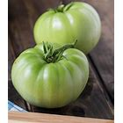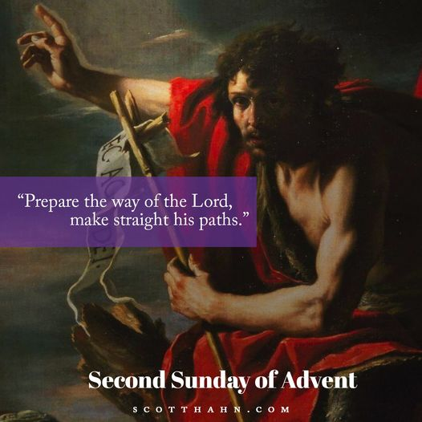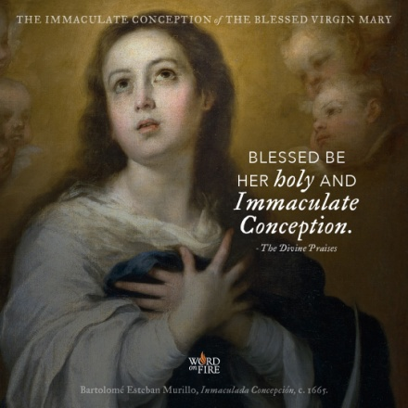
Happy Advent!
Yesterday was the Feast of the Immaculate Conception. I’m attaching an audio and printed file “Ode to the Immaculate Conception,” which I wrote many moons ago.
We are in the middle of Advent and have started our Advent Series of Homilies. I’m attaching four audio files for the four Sundays of Advent. The Advent theme is “Gifts to God,” which is our response to all that God has given to us: his Divine Life, his Son, his Holy Spirit, his Church and sacraments, especially the Holy Eucharist! The first homily is “Stay Awake!” the second is “Produce Good Fruit,” the third is “Here is Your God,” and the fourth is “Obedience to God.” Please listen to all four homilies. Let us become holy and fruitful and give holy hearts to God on Christmas day.

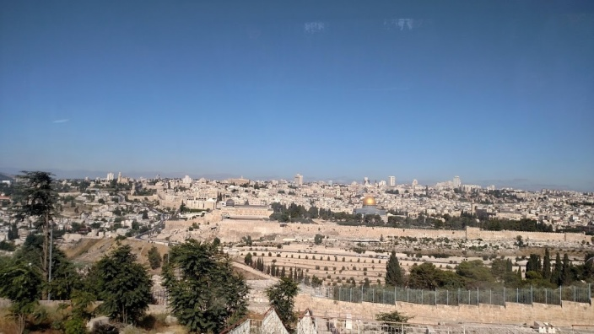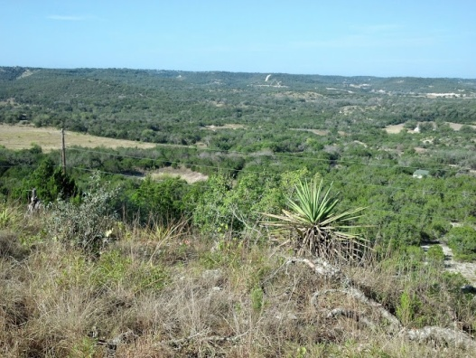

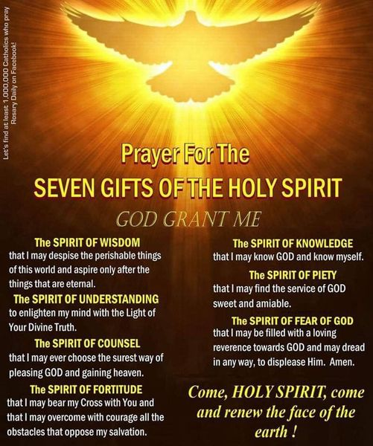

Mark your calendars for Saturday, January 28, 2023. I will have my sixth Day of the Lord Retreat. The theme is “A Day with the Holy Spirit, More than wind and fire.” We will look at how the Holy Spirit is “The Forgotten God,” his gifts and fruit that can make us saints and how the Holy Spirit is prominent in the mysteries of the Rosary. As in the past, we will have music, singing, table sharing, fellowship, prayer
and a great day with the Holy Spirit for only $10. It will start at 800am and finish at 2:30pm.

I challenge you to continue to grow, continue to learn your faith, continue to pray more and more for the intercession of Mary, St Joseph, Jesus and the Holy Spirit. This is a marathon, not a 100 yard dash, but we must be diligent disciples on a daily quest for wisdom and grace.

Feel free to visit my website and promote it with others. Just copy and paste this link:
Church of the Holy Spirit | San Antonio, TX (holyspiritsa.org) and click “Holy Spirit Ministries”
It’s under “Men’s and women’s ministries.” At the top of my home page you can see a “Journal” tab. Just click it for all six previous issues of the “Green Tomatoes Journal”

I hope you enjoyed this issue. Please listen to audio files. You can download them, put them on a flash drive and then listen to them while you drive around town (newer model cars, of course). If you have any questions you would like to ask, or if you have a suggestion for a future journal issued, contact me at egwittig@outlook.com

Merry Christmas! I love you all!

Deacon Evan G Wittig

