Green Tomatoes Journal 6th Issue
Tuesday November 22, 2022 “As long as you are green, you grow.”

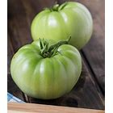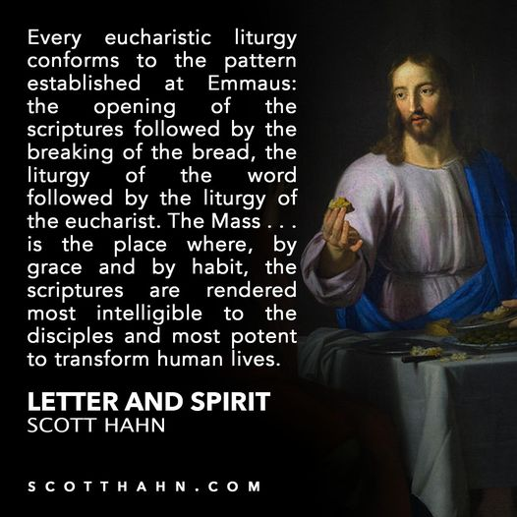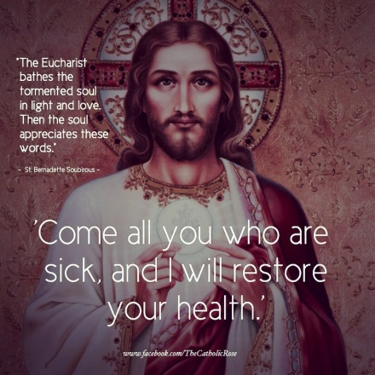
At every Mass we hear:
“The Lord be with you.”
“And with your spirit.”
“Lift up your hearts.”
“We lift them up to the Lord.”
“Let us give thanks to the Lord, our God.”
“It is right and just.”
“It is truly right and just, our duty and our salvation, always and everywhere
To give you thanks, Lord, Holy Father, almighty and eternal God.” (Preface)

This week of Thanksgiving is a good time to reflect on the Eucharist, which means, “Thanksgiving.” There is nothing better than God! There is nothing better than the Mass! It is the greatest romance, the greatest love story ever told!

Some people complain, “I didn’t get anything out of that Mass.” You get Jesus! You get God!
God shares his eternal, powerful, almighty, intimate, invincible, divine Life with You! Some Catholics don’t know, don’t understand, don’t believe, don’t live the Mass. I invite you to spend one hour a week this Advent, learning about the wonders of the Mass.
Come every Sunday. Come to participate. Come to pray. Come to sing. Come to listen. Come to glorify God. Come to sacrifice your life to God. Come to believe God. Come to receive God! Come to learn your faith!

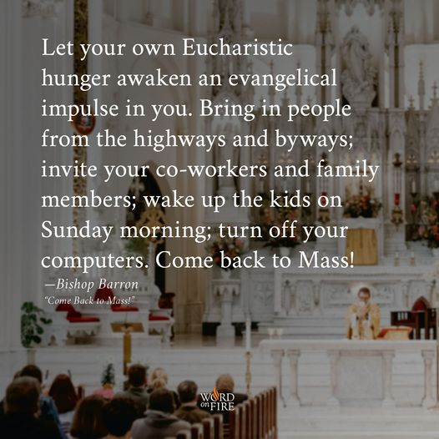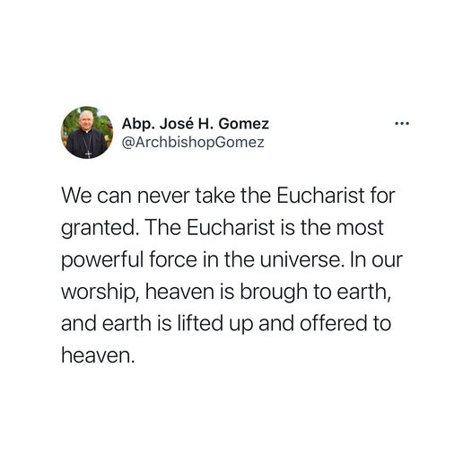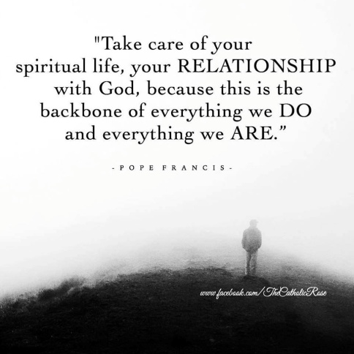

The following lesson, meditation, is from “All I ask is That You Love Me,” a devotional adoration companion I received from Medjurgorje this summer. If you would like a copy of this book, let me know (only $5 for shipping).
To celebrate Mass is to take part in the finest lessons of life. You learn how to live and die: you learn about friendship and love; you learn to forgive. You learn to be merciful and you learn how to give love to your enemies as well as your friends. By taking part in the Holy Mass, the individual is born again to a new life. He becomes the bread of life, the light and the way in this world so full of darkness. By taking part in Holy Mass, one is healed and so is able to heal others, and is made holy, so as to make others holy. Without it, (the Mass), the Christian life is
stripped of its life force! In this sacrifice, He is really Emmanuel, God with us and for us. St Teresa of Calcutta once said, “The cross is the symbol of how much Jesus loved us and the Eucharist is the symbol of how much God loves us.” (p 10).
Mary, the Mother of Christ, is the Mother of the Eucharist. She invites us the live the Eucharist, so that the Mass is Life and Life is Mass. She wants us to prepare for Mass, so that it can be the focus of our prayers. (Fr P. Devine C.S.Sp.)

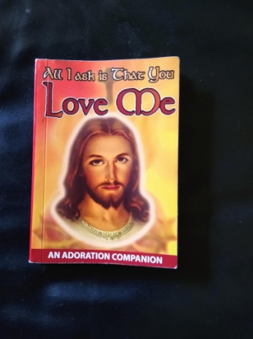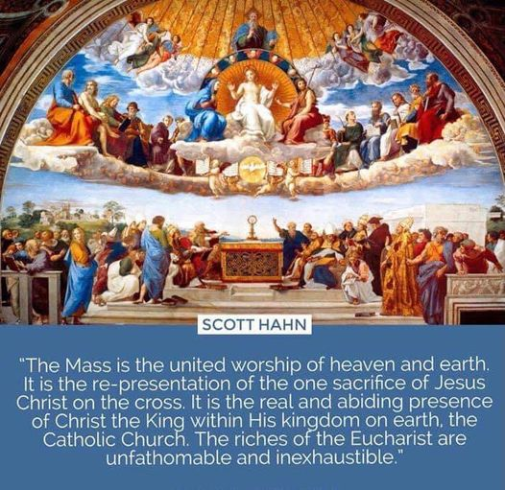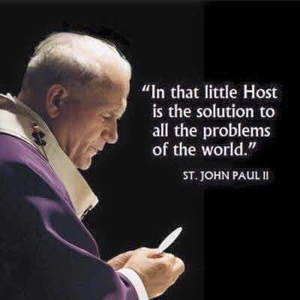

During this Advent, Holy Spirit is having an Advent Series of Sermons with the theme: “Gifts to God.” What are you giving to God this Christmas? Come to all four homilies for some great ideas! To help you learn more about the Mass and it’s meaning, I’m attaching two poems “Eternal Bread” and “Mystical Body”. I also have for you four audio files: “Mystical Body,”
“God Gives Himself,” “Holy Communion,” “You in Heaven.” My power point: “Nothing is Better Than the Mass” is an in depth look at all the parts of the Mass.

I also recommend two fine you tubes:

1) Fr. Mike Schmitz: "The Hour That Will Change Your Life" | SEEK2015 Fr. Mike Schmitz shares his experiences and the true intimacy that the Lord offers us in the Eucharist.
2) The Mass Explained - Explaining the Faith - Bing video Fr Chris Alar (two one hour sessions)

Remember, we are students for life! The more we know and love God and the wonderful gift of himself at the Holy Mass, the more we can give ourselves back to God at every Mass. The Mass is our sacrifice to God joined with the eternal sacrifice of Jesus Christ, his Son. It is the source and summit of our Christian faith. I hope you enjoyed this issue of “Green Tomatoes.” Please email me with thoughts and suggestions for future issues (egwittig@outlook.com)

I love you all!

Deacon Evan G Wittig

