Green Tomatoes Journal 5th Issue
Monday October 31, 2022 “As long as you are green, you grow.”

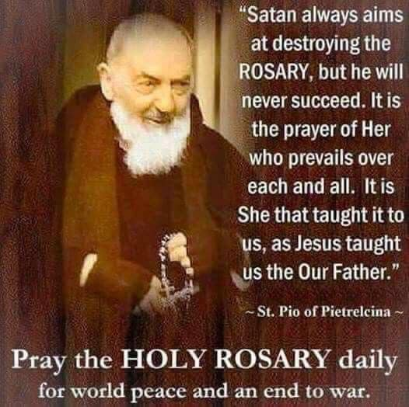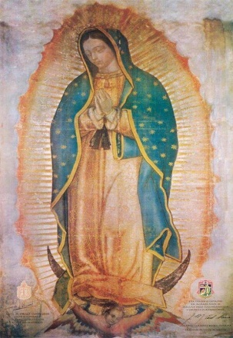

Happy Halloween! I’ll be out with the grandkids tonight, watching their house while they go trick or treating with their parents. So, I couldn’t let the Month of the Rosary go by without promoting praying the rosary well.

Last Thursday, October 27, we had a very famous reading of St Paul to the Ephesians, chapter six: Finally, draw your strength from the Lord and from his mighty power.
Put on the armor of God so that you may be able to stand firm against the tactics of the devil.
For our struggle is not with flesh and blood but with the principalities, with the powers, with the world rulers of this present darkness, with the evil spirits in the heavens. (v10-12).
Our armor consists of: truth, righteousness, evangelization, faith, salvation and the “sword of the Spirit, the word of God” (v17). There was a Bishop in Africa who prayed for help with a local terrorist group that threatened his people. Jesus appeared and gave him a sword, which changed into a rosary! St Padre Pio called the rosary “my weapon.” In Revelation Chapter Twelve, we have the “woman, clothed with the sun with the moon under her feet;” this, of course is Mary. She does battle with Satan by bringing Jesus, the Son of God, into the world. Folks, that battle is still raging! Sr Lucia of Fatima told us that the last great battle between Jesus and Satan would be over the family. People, we are here now at the last great battle! Marriage has been re-defined to include two people of the same sex. Many people don’t even bother to get married, or to ask for the sacrament of Matrimony. The government has replace husbands and fathers with a government hand out. Divorce is rampant and many young people today are talking about not having any children at all!

Mary said, “In the end, my Immaculate Heart will triumph.” How can this be? By praying the rosary daily! Review my July Issue of “Green Tomatoes” to see how Mary triumphs, but the rosary is one of her key weapons. To pray the rosary is not just to recite the prayers, it is to meditate on each of the mysteries and apply them to your lives. Put yourself in the place of Mary, what would you do? Be a disciple, be one of the shepherds, be Joseph, be Simeon, be John the Baptist. Be by the foot of the cross with Mary and John and hear Jesus’ last worlds, “It is finished. Father, into your hands I commend my Spirit.”

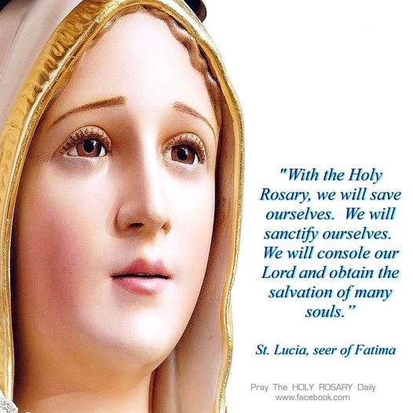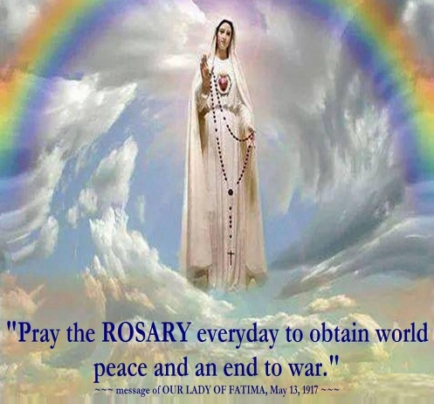

As we meditate on God’s word revealed in each mystery, we learn to love Jesus and Mary more and more, we discover the wonders of our redemption, reconciliation, restoration and sanctification. We discover our true identity as children of God and disciples of Jesus Christ.
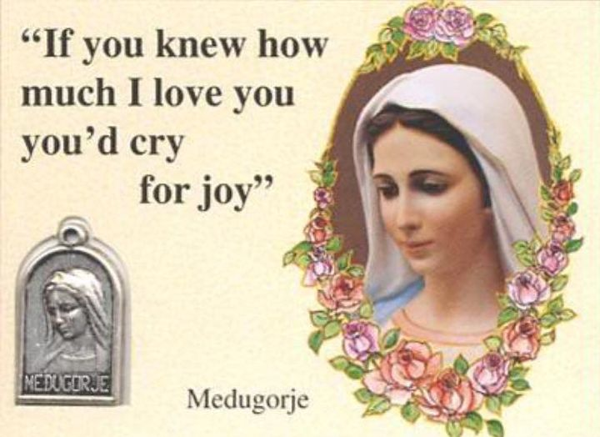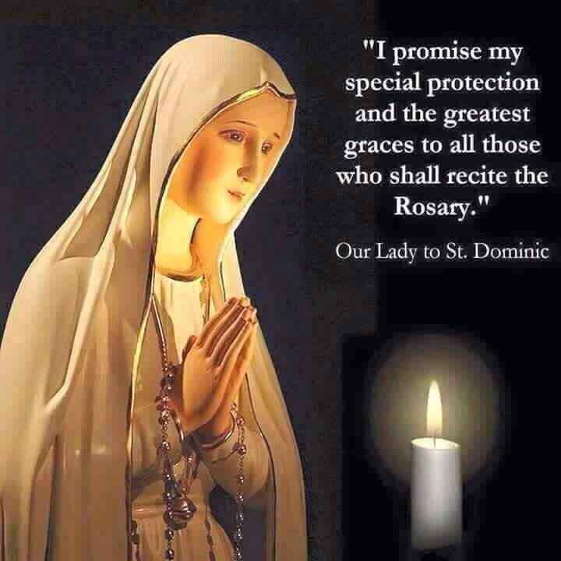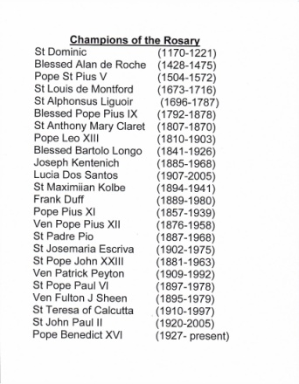

Our faith will grow, we will grow in holiness, in joy and peace and the power of prayer!
Every “Hail Mary” is a blow to Satan’s head! We remind him of his fall from grace, how God prefers “The Woman,” Mary, over him. Every rosary is 53 red roses for Mary and six white roses for Jesus. Many saints and holy people were champions of the rosary. Why don’t we join their company by choosing to become saints? We can do this!

Fr. Don Calloway on the Power of the Rosary, check out this you tube:
https://www.youtube.com/watch?v=x1tH_zQ-Cz0&feature=youtu.be

I have attached a few files that will help you pray the rosary better. I have uploaded new power points, homilies, songs and articles on my website:
https://holyspiritministrysatx.com/home-green-tomatoes just copy and paste this link.
God bless you. I love you all. Until the next issue, I remain faithfully yours,

Deacon Evan G Wittig

