Green Tomatoes Journal 4th Issue
Wednesday September 21, 2022 “As long as you are green, you grow.”

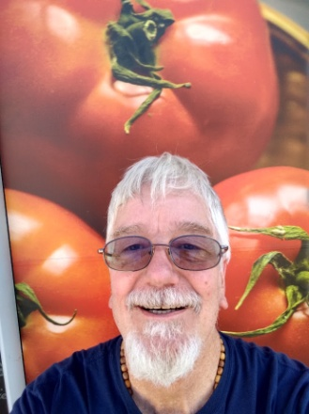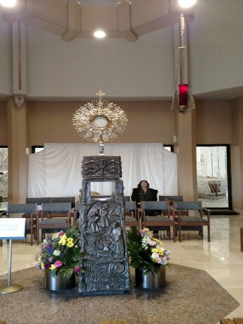

Well, my friends, here we are with the 4th issue of the Green Tomatoes Journal! At Mass this morning, the readings for the feast day of St Matthew the Apostle, we have Paul’s letter to the Ephesians: St Paul wrote: “I, then, a prisoner for the Lord, urge you to live in a manner worthy of the call you have received, with all humility and gentleness, with patience, bearing with one another through love, striving to preserve the unity of the spirit through the bond of peace: one body and one Spirit, as you were also called to the one hope of your call; one Lord, one faith, one baptism; one God and Father of all, who is over all and through all and in all.” (Eph 4.1-5) While this whole journal article could be about Eph 4, I want to focus on how Paul had developed the theme of the Church as the body of Christ, with Christ Jesus as the head of the body.
Once during adoration of the Holy Eucharist, I contemplated how the Host was the body, blood, soul and divinity of Jesus Christ. We are joined to the Mystical Body of Christ (MBC) at baptism and holy communion maintains our union with Jesus Christ, our head. Since the Host is Jesus, can you apply what you say about Jesus to the Host? Sure, why not? You can look at the exposed Host, or just pray to Jesus in the tabernacle, or pray to Jesus after you receive him in holy communion and say: “Welcome, my Lord and my God, my savior, my redeemer, my healer, my life, my joy, my rock, my fortress, my strength, my peace. I am holy, O Lord Jesus Christ, because you are in me and I am in you!” While your eyes see the Host, let your heart and your faith and your mind see the person of Jesus Christ, risen from the dead and seated at the right hand of the Father.
Is the fullness of the Trinity in the Host? Yes. Is eternity in the Host? Yes. Is the whole Church present? Yes. Is the One Man (Jesus) present, uniting all things in himself? Yes. When we say the Church is the body of Christ, do we mean that literally, or is it a metaphor? The Church literally is the Mystical Body of Christ.
I am attaching a document, “The Host and the Mystical Body of Christ,” which goes into more detail on this topic. I also have attached an audio file with the same title you can listen to.
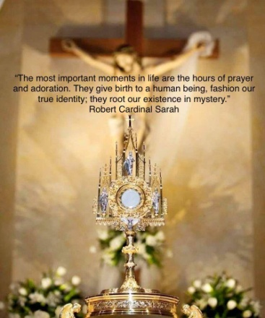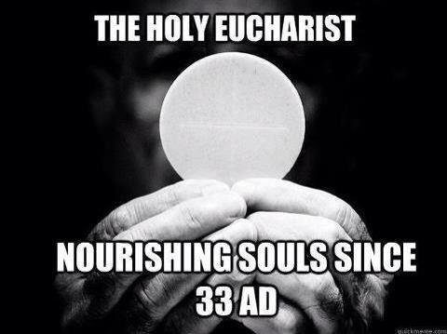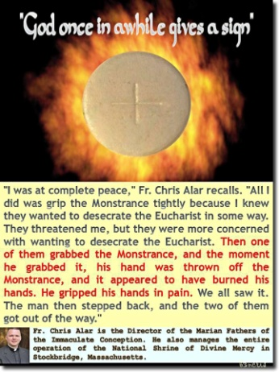

I have been reading a little book called “All I Ask is that You Love Me,” published by the Medjugorje Herald. It is full of wonderful quotes and meditations from some great saints. Here is a sample:
Jesus said to St Margaret Mary, “I thirst with such a terrible thirst to be loved by you in this most Blessed Sacrament.” “What can I desire on earth, or hope for in heaven but you, my Jesus! You are the God of my heart.” (St Francis de Sales). “Among all the devotions, after that of receiving the sacraments, that of adoring Jesus in the Blessed Sacrament holds first place.” (St Alphonsus Liguori) “Just as he appeared before the holy Apostles in the true flesh, so now he has us see him in the Sacred Bread.” (St Francis of Assisi) If you are interested in this book, email me and I will mail it to you for $5 total (cash or check will be fine).
I have expanded my adoration of Jesus from one hour a week to seeing him at least a little while every day. The more I adore Jesus the more I love Jesus and the more I want to adore Jesus. Won’t you join me in adoring the One True God?
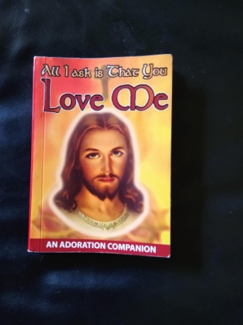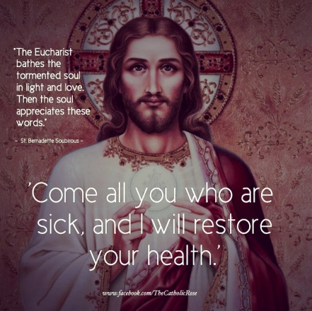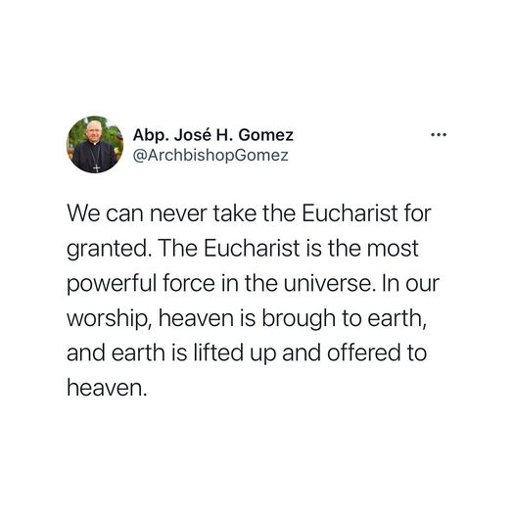
I have uploaded new power points, homilies, songs and articles on my website:
https://holyspiritministrysatx.com/home-green-tomatoes just copy and paste this link and you are there. Let me know if there is something you would like to learn more about, or if you have any questions I can try to answer for you. Be a good student, now, I want to hear from you.
God bless you. I love you.

I hope you enjoyed this issue. Thanks for your precious time! Until the next issue, I remain faithfully yours,
Deacon Evan G Wittig

