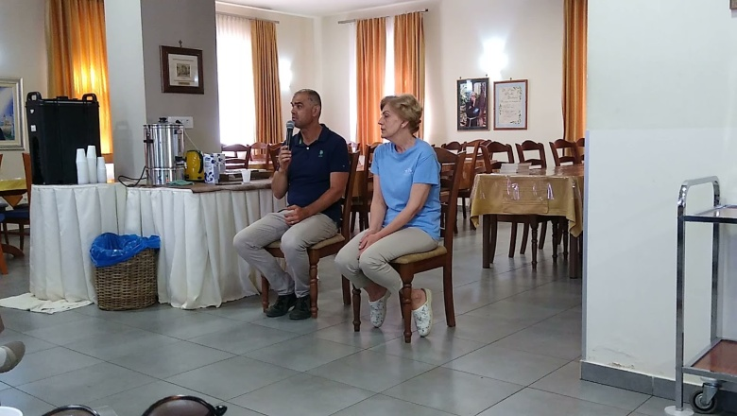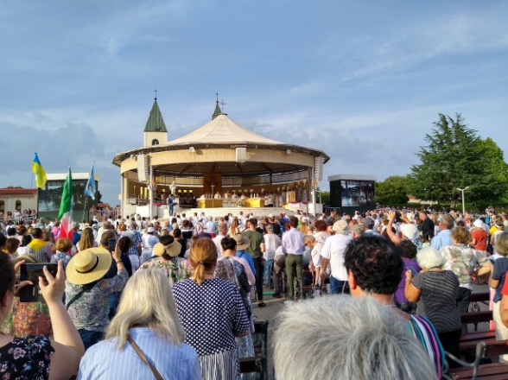

We met with Mirjana and she told her story of how the visions with Mary began. Over 15 to 20 thousand people gathered outside all during the week I was there. Below: the view from Apparition Hill. Statue of Mary carried in Saturday night procession. “Risen Christ” bronze sculpture.

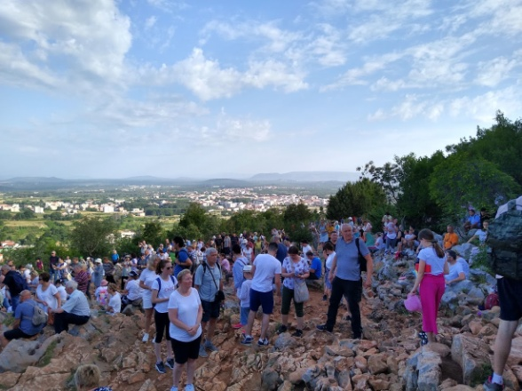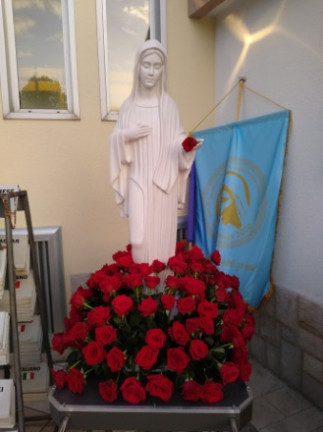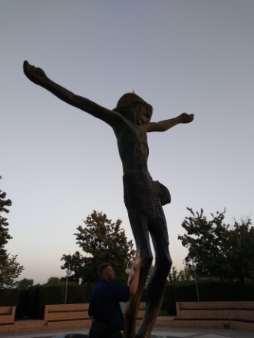

My website will have continued updates, including homilies and teachings. Feet free to visit it: https://holyspiritministrysatx.com/home-green-tomatoes

Thanks for your precious time!
Until the next issue, I remain faithfully yours,

Deacon Evan G Wittig

Medjugorje retreatants,
If you would like emails like this once or twice a month, email me at egwittig@outlook.com and say “Please enroll me in your Green Tomatoes email community.” Just leave your name, phone and email address. That’s it. – Evan Wittig

