Green Tomatoes Journal 3rd Issue
Tuesday August 16, 2022 “As long as you are green, you grow.”

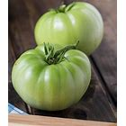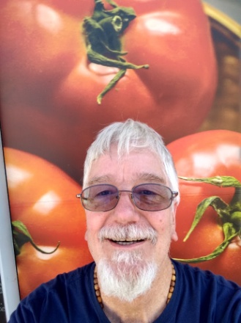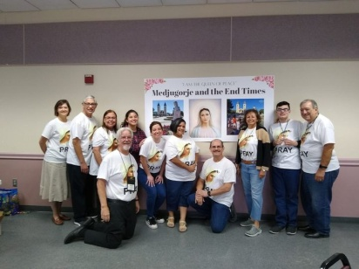

Thank you for saying “yes” to my Green Tomatoes Community.
A Christian is a disciple, a student, of Jesus Christ. I’m always learning and I love it! I hope sharing some thoughts and insights with you will help you continue to grow. This issue reflects my recent retreat: Medjugorje and the End Times” given Saturday, July 30, 2022.

I gave this retreat because I believe we are living in the end times. It began with the writings in the New Testament (see attached “End Times” Fact Sheet). We should be ready to face Jesus today, tomorrow, ten years from now. This lesson was brought home to me explicitly. The readings on August 7 had Jesus telling his disciples, “Be ready, you know not the day or the hour of my coming.” Last Tuesday, August 9, my sister in law Patty Wittig had a terrible fall and was placed on life support. The local Wittig family, her son Craig and his wife Katy, and her brother Kevin, all spent time at her side and said good bye. She was only 75 when she passed away August11. We are all going to miss her love and joy. “Everybody loved Patty. Patty loved everybody.”

The retreat was a great success. We had 82 retreatants and most gave it an excellent review. I told the story of Medjugorje (I invite you to watch the attached power point). If Mary has been appearing there since 1981, then we must ask the question, why? Is she preparing us for something as great as the second coming of Jesus? Is she revealing her plan to defeat Satan? Will her Immaculate Heart triumph over the evil we see in the world today? Is there a warning coming upon the world, a chastisement from God? Read the “Why Are We Here?” attachment to appreciate the importance of the retreat. Mary has given many message and instructions over the last 41 years (see attached “Message Samples for Folder”). Mary came to call the world to conversion, prayer, fasting, penance and peace.

I know many people cannot give up a Saturday for a retreat, so I am offering you a chance to benefit from that day of praying, singing, learning and sharing. I have posted many of the documents I handed out that day on my website:
http://holyspiritministrysatx.com/home-green-tomatoes/
Feel free to visit and download any number of documents and power points and audio files. The “Ten Secrets and the Five Stones” give a preview of what could be coming soon upon the world and how Mary is preparing the world for it. “Mary’s Medjugorje Plan” reveals her plan to defeat Satan. There is a short file of her messages (Message Samples for Folder) and a big file of messages (Message Samples). There is an audio file telling the story of the first seven days of apparitions and my “Sun Miracle” which took place there during Mass and right before the “Best Homily” which I summarized shortly after I heard it. I am attaching my “I am the Bread” homily, I hope it will help love the Eucharist. Many good files are there for you to download.

I offered the retreatants two flash drives (see flyer). It contains presentations and documents and audio files and rosary meditations from all five of my past retreats. The computer version is $15.00 plus $5.00 for shipping. The rosary video version can be played in your automobile’s thumb drive port (newer models, of course; $20 plus $5 for shipping). You just play the rosary video and pray along with it, very popular with retreatants. I hope you will visit the website and take advantage of a great retreat.

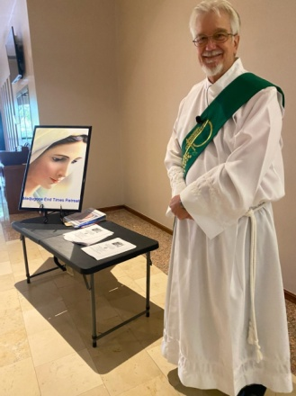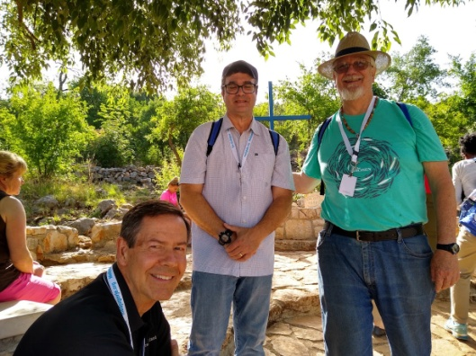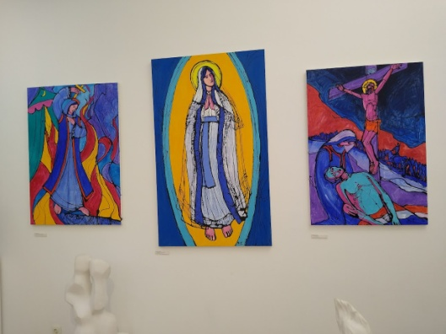

Promoting the retreat, fellow pilgrims, “Three Mary’s” near Medjugorje.
Below: Patty Wittig, rest in peace.

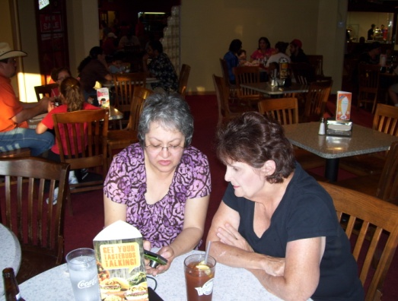 I hope you enjoyed this issue. Thanks for your precious time! Until the next issue, I remain faithfully yours,
Deacon Evan G Wittig

