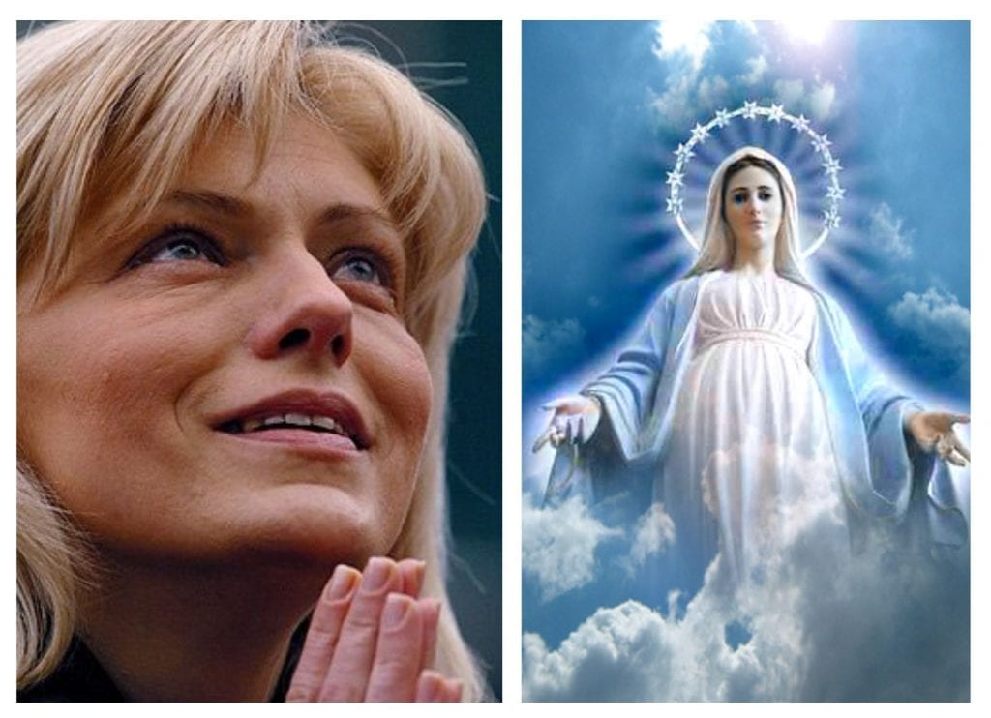
Five Retreat Flash Drive Flyer
The Day of the Lord Retreat
The Day of the Eucharist Retreat
A Day with Mary and the Rosary Retreat
A Day with the Holy Family Retreat
Medjugorje and the End Times Retreat
Many power point presentations from all retreats.
Many notes and source documents
Many Audio files from three retreats
Audio Rosary meditations for all twenty mysteries
Deacon Evan Wittig – 10 songs
Anthony Wittig - 4 songs
Matthew Kelly’s Seven Pillars of Catholic Spirituality
There’s an app for that!
Keep wanting to learn more about Jesus, Mary, our faith.
For computer only $15.00
Same drive with Rosary Video “Just play it and pray it.” only $20

