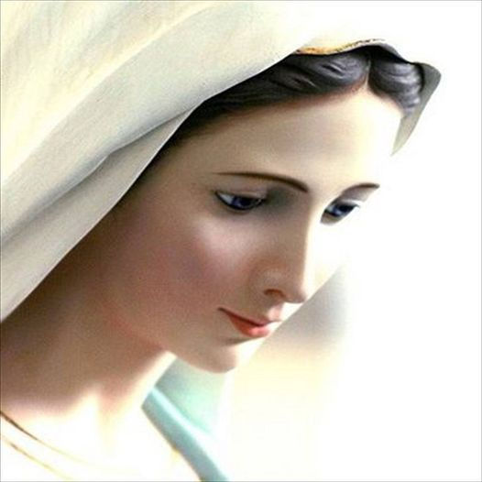

My children,
If you knew how much I love you,
You would cry tears of joy.
-your mother,
Mary

